University of Central Punjab 

**Faculty of Information Technology**

# Object Oriented Programming (C8)

|  |  |
| --- | --- |
| **Lab 10** |  |
|  | |

**Instructions:**

* Indent your code.
* Comment your code.
* Use meaningful variable names.
* Plan your code carefully on a piece of paper before you implement it.

**If the submissions are NOT on the portal, we will not mark them**

## Task 1

Create a Class **ReleaseDate** having Date of Release of Product. The Date should be in format day-month-year.

Create another class **Product** having the name of Product (char *); price(int); and Date of Release.

Identify the relationship and rest of functions needed for both of the classes and implement them.

In main create object of Product to show the full detail of every object e.g

|  |
| --- |
| Shampoo 200 12-02-2019  Soap 50 13-02-2018  Lotion 450 01-12-2019 |

Task 2

Create a class People having name, NIC,Address and DOB as its attributs.

DOB object belongs to a class DOB ,having day-dat-year as its attributes.

Mystring class has char*String as its attribute and Address has HouseNumber,City,And Country.

**Identify the relationship among all** and implement all the required functions in all classes to make them functional.

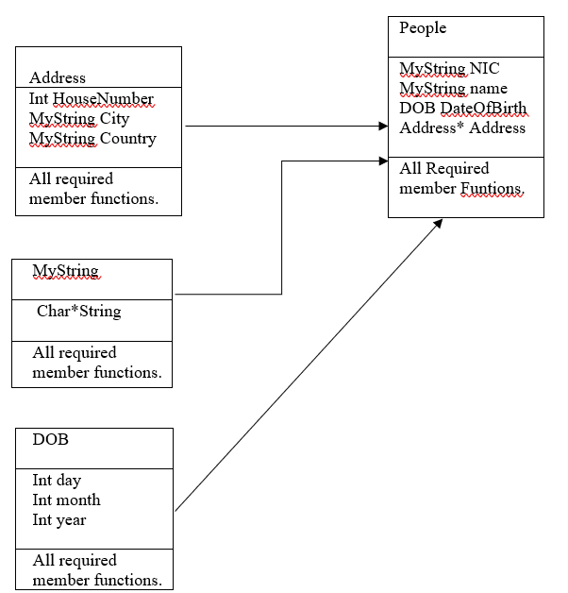

In main create object of People to show the full detail of People object

**Task 3:**

Define a class **MyChar** having one one private attributes: A single character variable.

**Now add the following operations on above mentioned class MyChar:**

1. Write parameterized constructor with default arguments.
2. Write separate setters for each attribute to set value.
3. Write separate getters for each attribute to get value.
4. Overload cin>> operator for MyChar.
5. Overload cout<< operator for MyChar.
6. A function that can convert the character stored in MyChar into lowerCase.
7. A function that can convert the character stored in MyChar into upperCase.

**Then, define a class MyString having following attributes:**

1. A **MyChar\*** to make an array of MyChar.
2. A count to maintain the number of MyChar in the array.

**Finally, add the following operations on above mentioned class MyString:**

1. Write **parameterized constructor with default argument.**
2. Write a copy Constructor.
3. Write an assignment operator.
4. Write a destructor.
5. Overload + Operator to concatenate two MyString objects.
6. Overload **cin>>** operator for MyString.
7. Overload **cout<<** operator for MyString.
8. Overload pre-increment and post-increment operator which converts the MyString into upperCase.
9. Overload pre-decrement and post-decrement operator which converts the MyString into lowerCase.
10. Write a print(const MyString&) function which should be a **non-member function** and you are **not** allowed to return **the memory handler** anywhere in your programme.

**Hint:** **Overload [] operator.**

**Remember:**

|  |  |  |
| --- | --- | --- |
| There should be no memory leakage in your programme. | | |
| Use const qualifier wherever possible. |  | |
| Your programme should compile and run properly. | |  |

**Write a driver programme(main()) to test “all” functionalities and operators of MyString class on your own.**